

Department of Computer Science

MY University, Islamabad.

**Implementation Phase (LAB)**

**Project No: 03**

**Course Title: Database System**

**Student Name: Taha Saddiqui**

**Registration No: baib232005**

**Batch: Fall2023**

**Program: Ai**

**Semester: 6th**

**Lab Instructor: Mr. Hamza Javed**

**Submission Date: 20/04/24**

**Question 1:** University management System

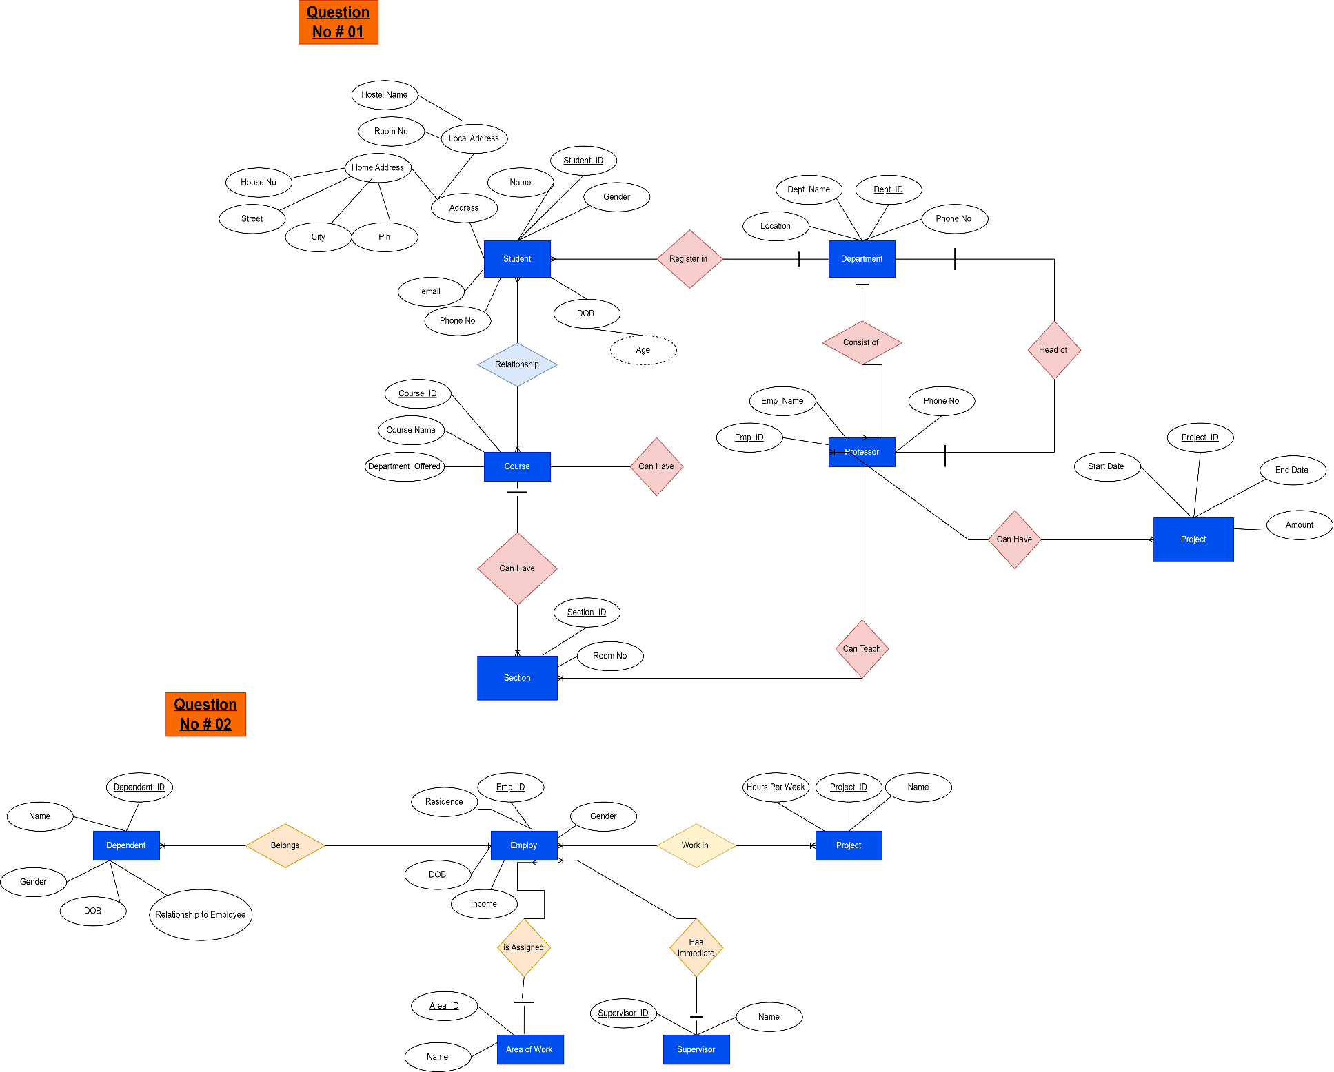

**Question 2:** Social Security Firm

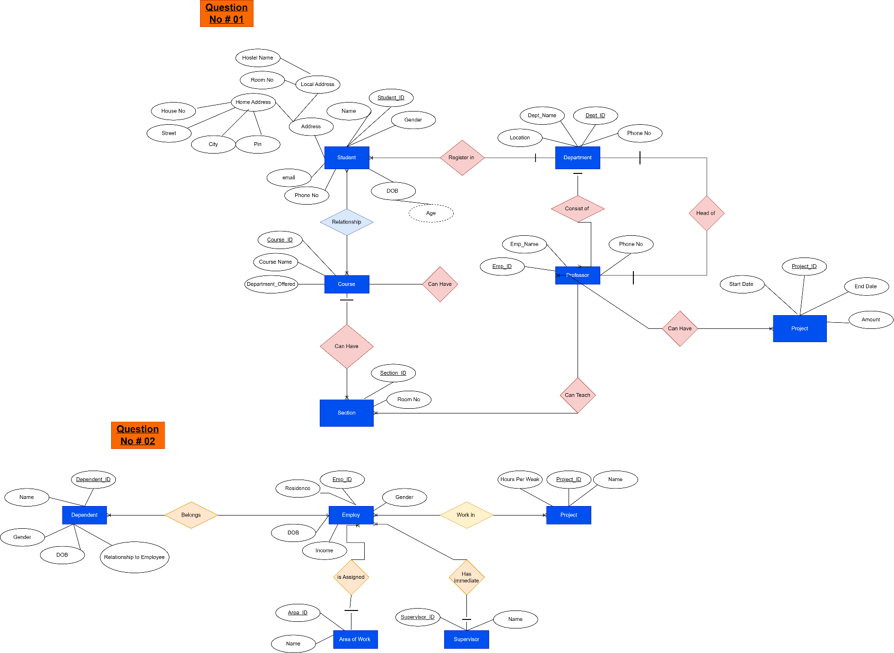

**Question 3:** L & M pet grooming management System.

